Experiment. No.03
Title: Demonstration of frequency reuse concept in cellular systems using Python.

Aim: Demonstration of frequency reuse concept in cellular systems using python.
Requirement:
• Python 3.x
• NumPy
• Matplotlib

Theory :

Cellular Communication System
A cellular communication system divides a large geographical area into many small regions called cells.
Each cell has
- Base Station (BS)
- Mobile Users
- Assigned Frequency Channels
Instead of assigning unique frequencies to every cell, the same frequencies are reused in cells that are sufficiently far apart. This concept is known as Frequency Reuse.

Frequency Reuse
Frequency reuse means assigning the same frequency channels to multiple cells separated by a minimum distance to avoid interference.
Each cellular base station is allocated a group of radio channels to used within a small geographic area called a cell. Base stations in adjacent cells are assigned channel groups which contain completely different channels than neighboring cells. The base station antennas are designed to achieve the desired coverage within the cell. By limiting the coverage area to within the boundaries of a cell, the same group of channels may be used to cover different cells that are separated from one another by distances large enough to keep interference levels within tolerable limits. The design process of selecting and allocating channel groups for all of the cellular base stations within a system is called frequency reuse or frequency planning

Why Frequency Reuse?
Because wireless spectrum is limited.
Frequency reuse
- Increases network capacity
- Supports more users
- Improves spectrum utilization
- Reduces infrastructure cost

Algorithm
- Import libraries.
- Define cell radius.
- Create hexagonal cells.
- Assign frequencies.
- Repeat frequencies after cluster completion.
- Display cells using different colors.
- Observe reused frequencies.

Procedure:
- Go to https://colab.research.google.com
- Click New Notebook.
- Copy the Python code provided.
- Paste it into the first code cell.
- Click the ▶ Run button or press Shift + Enter
- Observe the output
Python Code
import matplotlib.pyplot as plt
from matplotlib.patches import RegularPolygon
import numpy as np

# ------------------------------------
# Hexagon parameters
# ------------------------------------
R = 1.0
dx = 1.5 * R
dy = np.sqrt(3) * R

# ------------------------------------
# Colors for the 7 cells
# ------------------------------------
cell_colors = {
'A': 'red',
'B': 'blue',
'C': 'green',
'D': 'orange',
'E': 'purple',
'F': 'cyan',
'G': 'yellow'
}

# ------------------------------------
# Seven cells in one frequency cluster
# ------------------------------------
cluster = [
(0, dy, 'B'), # Top
(-dx, dy/2, 'G'), # Upper-left
( dx, dy/2, 'C'), # Upper-right
(0, 0, 'A'), # Centre
(-dx, -dy/2, 'F'), # Lower-left
( dx, -dy/2, 'D'), # Lower-right
(0, -dy, 'E') # Bottom
]

# ------------------------------------
# Position of the three 7-cell clusters
# ------------------------------------
cluster_offsets = [
(0, 0), # Upper cluster
(-3*R, -2*dy), # Lower-left cluster
(1.5*R, -2.5*dy) # Lower-right cluster
]

# ------------------------------------
# Create all cells
# ------------------------------------
cells = []

for ox, oy in cluster_offsets:
for x, y, label in cluster:
cells.append((x + ox, y + oy, label))

# ------------------------------------
# Draw hexagons
# ------------------------------------
fig, ax = plt.subplots(figsize=(8, 5.8))

for x, y, label in cells:

hexagon = RegularPolygon(
(x, y),
numVertices=6,
radius=R,
orientation=np.radians(30),
facecolor=cell_colors[label],
edgecolor='black',
linewidth=2.0,
alpha=0.7
)

ax.add_patch(hexagon)

# Cell label
ax.text(
x, y, label,
ha='center',
va='center',
fontsize=11,
color='black',
fontweight='bold'
)

# ------------------------------------
# Figure settings
# ------------------------------------
ax.set_aspect('equal')

ax.set_xlim(-6, 6)
ax.set_ylim(-7.5, 3)
ax.axis('off')

# ------------------------------------
# Title
# ------------------------------------
ax.text(
-5.1, 2.65,
'Frequency Reuse',
ha='left',
va='top',
fontsize=11
)

plt.tight_layout(pad=0.2)
plt.show()

Output: Frequency reuse for cluster size N=7

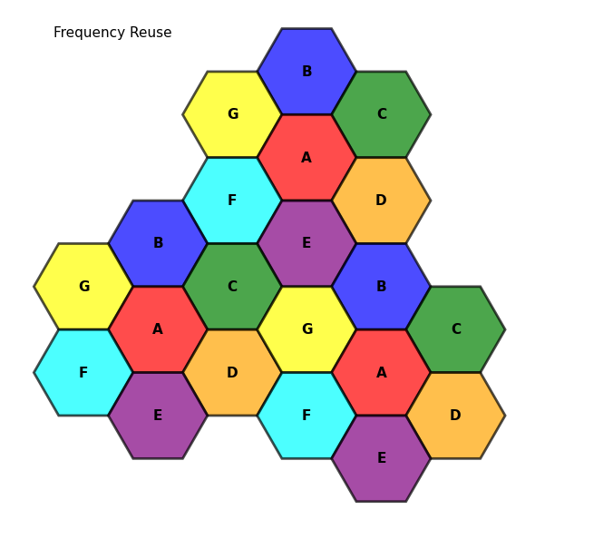

Advantages
• Better spectrum utilization
• Supports more users
• Increased network capacity
• Reduced interference
• Lower operational cost

Conclusion:
The simulation successfully demonstrates the frequency reuse concept in a cellular communication system. It shows how a limited set of frequencies can be reused across multiple cells without causing significant interference, thereby improving spectrum utilization and increasing network capacity.

